This mapping assignment consisted of using available information to develop mapping data for analysis. The first part of the assignment was to become familiar with the mapping system by selecting a base style map. I chose a map with imagery and labels as I liked the look of the topographic details it provided. This type of map works well with information requiring city, state and county labeling. However after inputting in data required in this assignment the map I chose didn’t fit within the criteria, so I had to change the map base to a different graphic style. This new style allowed input data of San Diego Trolley lines, with household income to be more visible. Household income reflects highest income of more than $82,000 to the lowest of $24,000 or less. Using income level along with trolley lines the data shows that the municipal of San Diego has provided its trolley lines in the majority of the areas with lower incomes.

A second part of this assignment required mapping tectonic Pacific Plate along with the Newport-Inglewood, Rose Canyon Fault zone, in San Diego. This information can be used in future building along the fault line along with strengthening of current infrastructure.

Web publication of the map created using this system, provides a professional data information map that can be used in a number of applications, over time to predict future economic and demographic patterns. Graphic’s provided include a full view of the map legend as opposed to the non-web based application, which was in my opinion provided an easier reading capabilities.
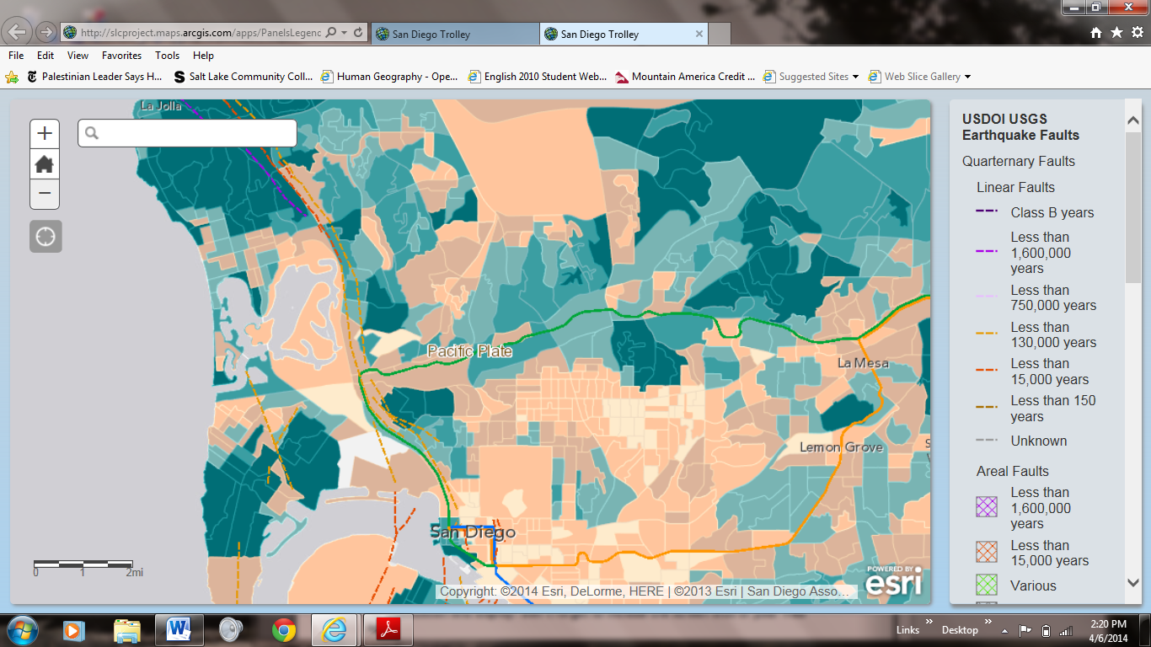

The third part of this mapping assignment allowed me to make my own map by selecting data I would find useful. I have to say this was the hardest part of the whole assignment as there was so much information out there I made numerous maps, but in the end I decided on population and transportation in the Utah Valley as a focus. I chose to incorporate income data along with where transportation lines currently in place within the state. Using web-based publishing I selected the Legend version for my map as I liked the readability of it. Viewing this map we can see there is a shortage of available transportation in high income newly developing cities. Details of this map may be viewed at http://bit.ly/1spu5as.

